***Quick Quiz***

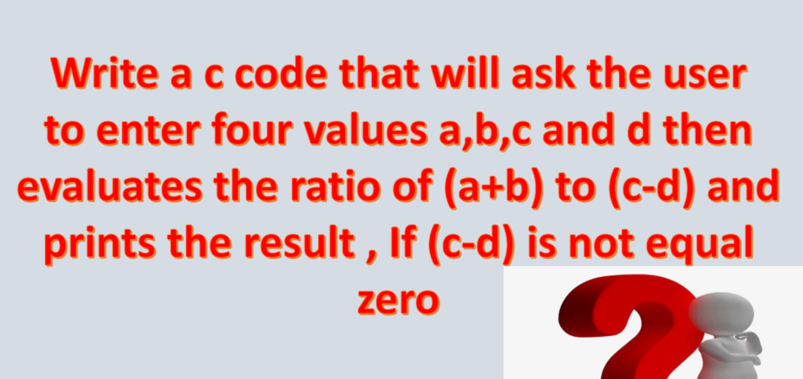

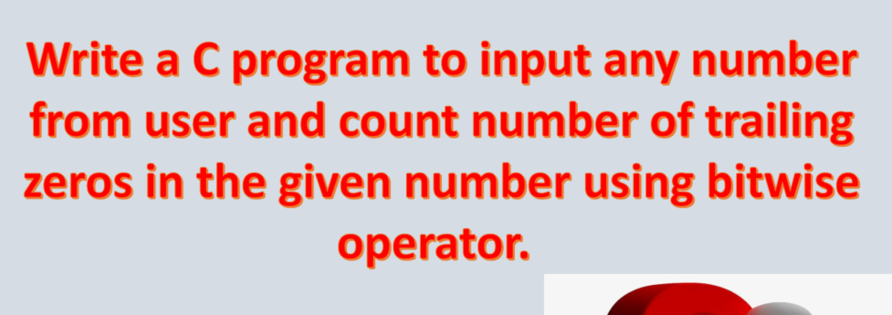

Problem in (enter a to exit) 🡪 Scanf(%d)

Prob. Shift operator applies only to integer cant do 2pow32 used 23

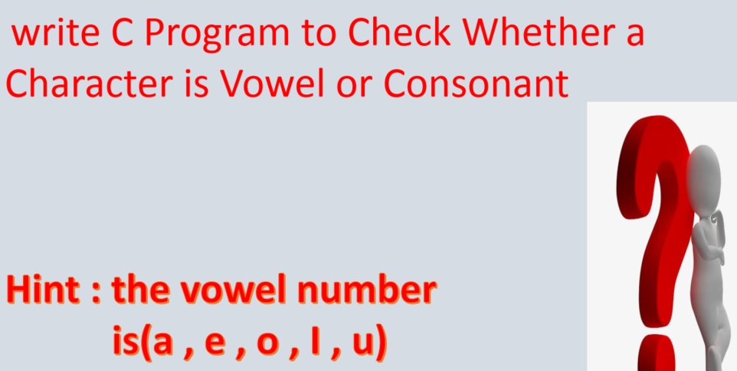

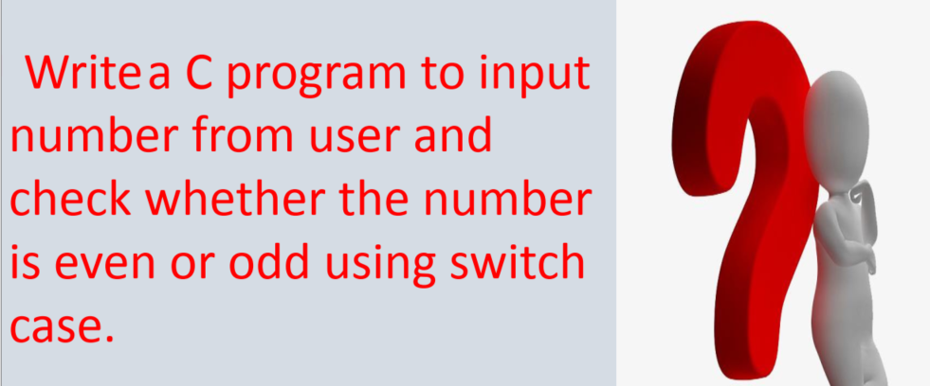

To : Abdallah

CC : [Hisham4ahmed@gmail.com](mailto:Hisham4ahmed@gmail.com)

[Quick quiz][ID]-----------